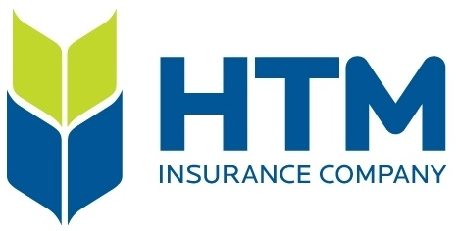 | Disconnecting from Work

Work Life Balance

Purpose & Scope | This policy applies to all employees of the HTM Insurance Co. In accordance with the amendments to the Employment Standards Act, 2000, as enacted on December 2, 2021 this policy addresses the expectations and responsibilities of the employer and employees on disconnecting from work, as defined, outside of scheduled working hours.
Definitions | Disconnecting from Work – As set out in the Employment Standards Act this is defined as “not engaging in work-related communications, including emails, telephone calls, video calls, or the sending or reviewing of other messages, so as to be free of the performance of work”.  Scheduled Working Hours- The hours that constitute each employee’s work commitment to HTM Insurance as set out by employment agreement and management direction. These hours are typically defined in daily and weekly increments. They are subject to change from time to time by way of attendance policies, vacation scheduling, statutory holidays, the nature of an employee’s role, and business requirements.
Disconnecting From Work | HTM Insurance expects that employees will not engage in work-related communications when not scheduled to work.  Employees are expected to make reasonable efforts to disconnect from work when not scheduled to work.  It is understood that employees may voluntarily choose to monitor work related communications at their own discretion during unscheduled hours, but this is not an expectation of HTM Insurance.  HTM managers and employees are encouraged to primarily send communications during core working hours. Should you choose to communicate outside scheduled hours, you should not expect colleagues to monitor or respond to communications until such time as such colleagues return to scheduled work.
Emergency Situations | In rare instances, there can be a significant emergency situation that requires the attention of some or all management. In the normal course of business, there are after-hours emergency claims or a claims event that may require service to our policyholders.
Related Documents | Employment Standards Act, 2000  Working for Workers Act, 2021  HTM Employee Information Handbook and Policies

