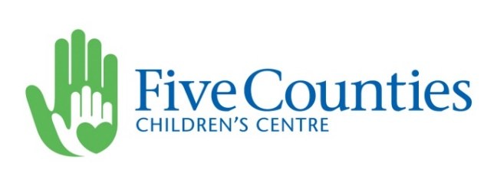
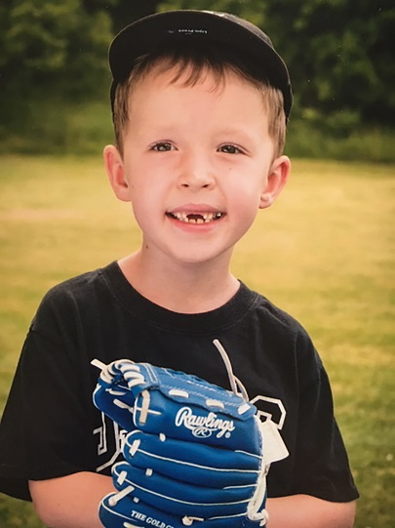

July 9, 2021

Mr. Alec Harmer, CIP
President & CEO
Meet Liam!
Hamilton Township Mutual Insurance Company
1185 Elgin Street West, Box 201
Cobourg, ON K9A 4K5

Dear Mr. Harmer,

Transformative - this is the best word to describe the impact of a gift on the children and families who come through our doors for help. Since 1975, Five Counties Children’s Centre has been a vital part of our community in expanding the availability of children’s treatment within our region. Five Counties Children's Centre is dedicated to supporting children and youth with physical, developmental and communication needs and their families. In partnership with families and communities we strive to enrich their independence and quality of life. We provide programs and services such as physiotherapy and speech and language therapy to help children walk, talk and most importantly some days just laugh and be a kid. We have offices located in Peterborough, Lindsay, Cobourg, Campbellford, and Haliburton/Minden areas.

In speaking with Bruce and Cindy Buttar, they shared their story of how their family has been helped through Five Counties services. I was also made aware there may be an opportunity for our organizations to partner to help the kids we treat. I am pleased to share information with you about one of our current projects in the hope that HTM Insurance Ltd. will consider investing in it and our kids.

Outdoor Treatment Space Creation Project

We realized during the recent pandemic that we needed alternative spaces to see and treat as many of our kids as possible. We have undertaken the Outdoor Treatment Space Creation project at our sites in Peterborough, Cobourg and Lindsay. We are pleased to share we received the funds need to complete our Peterborough backyard by this fall. Funds are still needed to move our Cobourg and Lindsay projects forward. In Cobourg, we have partnered with our tenant, the EarlyON Centre, to secure funding as this space will benefit all of our clients.

By adapting part of our property, we can enlarge our therapy space and make it safer so our kids can do this type of work in an outside setting where they can relax and enjoy their sessions in a new way. The specialized equipment we will purchase is specifically for outdoor use and can be used year-round. Therefore, this project the Centre will be able to see and treat more children as efficiently and effectively as possible than we can now due to changes in our delivery re: Covid-19 that are in place for the foreseeable future. Without it, we will see less children for treatment.

There are also many benefits of an outdoor treatment space that include:
- our therapists will be able to see more kids so they don’t end up on our waiting list

- the space can be enjoyed by all children coming to the Northumberland site, and focus on the ones for whom outdoor treatment would work best and/or is their only option
- enjoyment of fresh air, an open space, and nature assists with anxiety issues by reducing stress and helping to create feelings of calm, therefore it may also help reduce muscle tension, better preparing children for therapy where they need to be open and ready to interact with a therapist
- taking the children outside to do activities, especially the clients who are working on walking skills or developing balance by riding a bicycle for the first time - instead, they currently do these activities in the hallways or in the parking lot
- it would increase our capacity to book extra sessions for clients, thereby accelerating their development and opening our doors to more new clients

This project will benefit the 1,197 children, plus their families, in Northumberland County that we see on an annual basis to receive the services they need to thrive, when they need them.

HTM Insurance has created a strong culture of caring for communities and those they serve. You are committed to active community involvement and locally targeted charitable giving. We would be proud to partner with an organization that takes such pride in supporting initiatives that make a difference. Five Counties Children’s Centre also makes a significant difference to the all the communities we’re present in. Your business has most recently supported our kids with a gift to our Smilezone project at our Northumberland site. HTM Insurance’s continued support of Five Counties Children’s Centre will signal that all children have a place in our community – that we all deserve to live safe and healthy lives.

Every donation received to our Outdoor Treatment Space Creation project fund helps a child to go on to be the best they can be, to do things that weren’t thought to be possible. You’re not just helping them as children with physical, development and communication needs; their lives will be changed forever, and early intervention is key.

The cost of the project including equipment, materials and supplies, is $147,500. We respectfully ask your Board to consider a donation of $25,000 to help our kids to build their abilities for life. The therapy provided through your investment can make all the difference in the world to our kids to encourage confidence, independence and inclusion. Your support will help make our children’s goals of being their best a reality!

We would also be please to discuss with you what recognition opportunities are available in the event a donation is made to recognize your generosity and profile the support of your company. Should you require further information please don’t hesitate to contact me. I would be pleased to attend one of your meetings so I can share firsthand the importance and impact of our work.

Sincerely,

Lyn Giles

Lyn Giles, Director of Fund Development
1-888-779-9916, x381 www.fivecounties.on.ca
lgiles@fivecounties.on.ca Charitable Registration Number 12397 6342 RR0001

